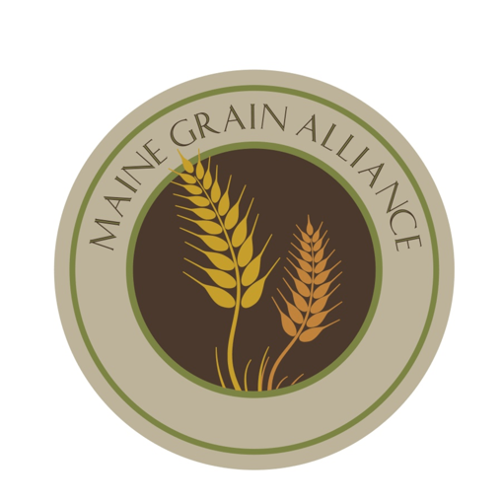

**Maine Artisan Bread Fair Vendor Application**

**Mail to**: Patti Dowse / Vendor Application

946 Dexter Rd, Cambridge, 04923

*Please send checks to PO Box 1140, Skowhegan, ME 04976*

Your Name (first and last):

Business Name:

Mailing Address (Street, City, State, Zip):

Business Address (Street, City, State, Zip):

Phone:

Email (if applicable):

Website (if applicable):

Do you require electricity?

Describe the nature of your product and/or services:

Provide a short description of how you think you will fit into the fair: